Output:

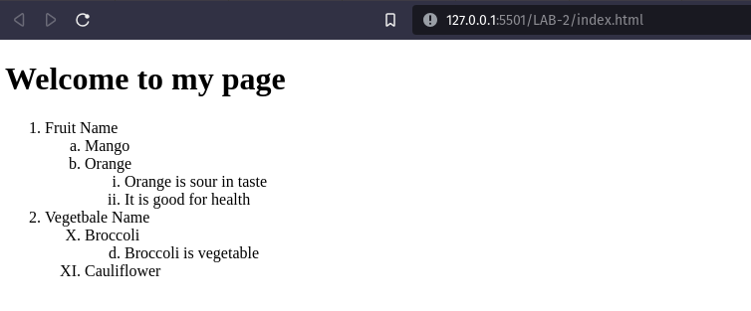

Conclusion:

Hence the objectives of lab were successfully implemented in HTML.

